New National Biogas and Organic Manure Programme (NNBOMP) – 2020

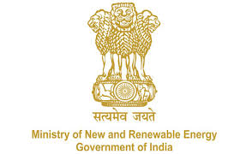

NNBOMP Information point (in case of doubts call us): 011-24360707; 24361920 Extn. 1047
https://mnre.gov.in/img/documents/uploads/dc65ef193ca9419f807441cfc193be3a.pdf

Implementing Agency Sanction Application Request Form
Form number: P2.S4_d ver. 1 (2020.05.10)

This form is developed for state implementing agencies requesting the MNRE for sanction of the projects identified during the demand assessment. The information will be stored safely in the Bio-gas portal. The form should be sent to biogas-mnre@gov.in.

Name of the Implementing Agency:
Contact person:
Telephone number:
Email address:

We are informing you that we have identified demand for installation of the biogas systems in our state. The identified demand has been assessed as of XX.XX.XXXX (date.month.year).

We have identified demand for installation of:

S.no. | Category | No. of plants (Total) | No. of plants (toilet linked)
1 | General
2 | Scheduled caste
3 | Scheduled tribe
 | Total

Date:

Sign

