New National Biogas and Organic Manure Programme (NNBOMP) – 2020

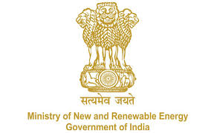

NNBOMP Information point (in case of doubts call us): 011-24360707; 24361920 Extn. 1047
https://mnre.gov.in/img/documents/uploads/dc65ef193ca9419f807441cfc193be3a.pdf

Installer registration request form
Form number: P3.S1.e_f_l ver. 1 (2020.05.10)

This form is developed for registering the installers. The form should be sent to biogas-mnre@gov.in . The sender can expect that the registration will be done in 48 hours. The information, together with the password will be sent together with the confirmation.

We request MNRE for registering us as an installer for the “New National Biogas and Organic Manure Programme (NNBOMP)” of MNRE, in the Bio-gas portal. Our details are as follows:

Name of the installer | Text
Category | Text
Address | Text
Pin code | Number
Contact person | Text
Phone number | Number
Training certificate Number | Number
Training certificate | Attachment
Aadhar no. | Number
Email id | Email
Website | Text
Short info | Text
Company registration no. | Aplha-numeric
Years of experience in installation of biogas plants | Number
Total biogas plants installed by you in the previous financial year | Number

Name of the Bank | Text
Branch address | Alpha-nuneric
Bank Account No. | Number
Type of Bank Account | Text
IFSC Code of Bank | Alpha-nuneric
Branch Code | Number
MICR code | Number

Date:

Sign

