New National Biogas and Organic Manure Programme (NNBOMP) – 2020

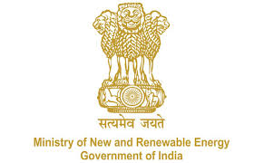

NNBOMP Information point (in case of doubts call us): 011-24360707; 24361920 Extn. 1047
https://mnre.gov.in/img/documents/uploads/dc65ef193ca9419f807441cfc193be3a.pdf

Implementing Agency Demand Request Form
Form number: P2.S1.l (e) ver. 1 (2020.05.10)

This form is developed to request the local bodies for assessing the demand in the areas assigned to them. The form contains the format for submitting the information.

We request you to assess the demand for Bio-gas systems to be implemented under the “New National Biogas and Organic Manure Programme (NNBOMP)” of Ministry of New & Renewable Energy, in the areas assigned to you & submit the details in the performa below:
Please note: The last date of receipt of the form is XX.XX.XXXX (date.month.year).

S.no. | Category | No. of plants (Total) | No. of plants (toilet linked)
1 | General
2 | Scheduled caste
3 | Scheduled tribe
 | Total

Date:

Sign

