New National Biogas and Organic Manure Programme (NNBOMP) – 2020

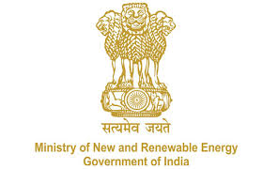

NNBOMP Information point (in case of doubts call us): 011-24360707; 24361920 Extn. 1047
https://mnre.gov.in/img/documents/uploads/dc65ef193ca9419f807441cfc193be3a.pdf

Inspector registration request form
Form number: P6.S1_d ver. 1 (2020.05.10)

Officials from BDTC, SNA, KVIC, NDDB, State Govt. Department & Financial Institutions can register as Inspector
This form is developed for registering the inspectors. The form should be sent to biogas-mnre@gov.in. The sender can expect that the registration will be done in 48 hours. The information, together with the password will be sent together with the confirmation.
I’m hereby registering myself as the Bio-Gas inspector to the bio-gas portal. I am aware that I would be able to inspect plants when the registration is confirmed by the appropriate agency.
I am also instructed, that the inspection process will be done using mobile application.
Please enter the mobile phone number to be used during inspection - time to time text messages can be send to you by the system.
Name | Text
Date of birth | Date
State | Text
Phone number | Number
Email to contact | email
Name of biogas training attended | Text
Agency to be affiliated | Text
Designation in the organization | Text
Comment | Text
Photograph | attachment

Date:

Sign

