New National Biogas and Organic Manure Programme (NNBOMP) – 2020

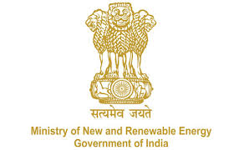

NNBOMP Information point (in case of doubts call us): 011-24360707; 24361920 Extn. 1047
https://mnre.gov.in/img/documents/uploads/dc65ef193ca9419f807441cfc193be3a.pdf

Implementing Agency & Local Body Registration Form
Form number: p1_s1_f_l ver. 1 (2020.05.10)

This form is to be submitted by the state agency and local bodies. The information will be stored safely in the Bio-gas portal .The form should be sent to biogas-mnre@gov.in . The sender can expect that the registration will be done in 48 hours. The information, together with the password will be sent together with the confirmation. Please note that the email address will be used as login. The name of the contact person, his/her phone number and email address will be visible to the public.

We request MNRE for registration of our agency, implementing the “New National Biogas and Organic Manure Programme (NNBOMP)” of MNRE, in the Bio-gas portal. The details of our agency are as follows:

Name of the agency | (text)
Are you a nodal agency | Yes/no
Type of the agency | State Nodal Agency/ local body
Superior agency | (text)
State | (text)
Address | (text)
Contact person | (text)
Phone number | (text)
Email to contact | (text)
Website | (text)
Logo | attachment
Short description | (text)

Date:

Sign:

